

**CAPSTONE PROJECT REPORT**

**Report 3 – System Requirement Specification**

– Ho Chi Minh, October 2020 –

**Table of Contents**

I. Project Report 3

1. Status Report 3

2. Team Involvements 3

3. Issues/Suggestions 3

II. System Requirement Specification 4

1. Overall Description 4

1.1 Product Overview 4

1.2 Business Rules 5

2. User Requirements 6

2.1 Overview 6

2.2 <<Feature Name 1 – i.e Order Meals>> 7

2.3 <<Feature name 2 – i.e: Meal Subscriptions>> 10

2.4 <<Next Feature Name..>> 11

3. Functional Requirements 12

3.1 System Functional Overview 12

3.2 <<Feature Name 1>> 13

3.3 <<Feature Name 2>> 14

4. Non-Functional Requirements 15

4.1 External Interfaces 15

4.2 Quality Attributes 16

5. Other Requirements 18

5.1 Appendix1 - Messages List 18

5.2 Appendix2 - … 18

# I. Project Report

## 1. Status Report

|  |  |  |  |
| --- | --- | --- | --- |
| **#** | **Work Item** | **Status** | **Notes (Work Item in Details)** |
| 1 |  | Pending |  |
| 2 |  | In Progress |  |
| 3 |  | Completed |  |

## 2. Team Involvements

|  |  |  |  |
| --- | --- | --- | --- |
| **#** | **Task** | **Member** | **Notes (Task Details, etc.)** |
| 1 |  | KienNT |  |
| 2 |  | TuanTV |  |
| 3 |  | AnhLM |  |

## 3. Issues/Suggestions

|  |  |  |  |
| --- | --- | --- | --- |
| **#** | **Issue** | **Status** | **Notes (Solution, Suggestion, etc.)** |
| 1 |  | Pending |  |
| 2 |  | In Progress |  |
| 3 |  | Completed |  |

# II. System Requirement Specification

## 1. Overall Description

### 1.1 Product Overview

### 1.2 Business Rules

|  |  |
| --- | --- |
| **ID** | **Rule Definition** |
| BR-01 | Must log in to the application |
| BR-02 | Must select level to access lesson |
| BR-03 | Must complete the current lesson to unlock next lesson |
| BR-04 | To complete a lesson, take a quiz |
| BR-05 | Estimate time of loading lesson to lesson screen about 3 to 5 seconds |
| BR-06 | Estimate time of uploading to server about 30 to 60 seconds |
| BR-07 | Must have an account |
| BR-08 | Must have a unique username |
| BR-09 | Must learn at least one lesson |
| BR-10 | Must have internet connection |
| BR-11 | Must have title in create post |
| BR-12 | Must have content in create post |
| BR-13 | Audio record max length is 2 minutes |
| BR-14 | Video record max length is 2 minutes |
| BR-15 | Audio comment max length is 1 minutes |
| BR-16 | New account must have to choose level |
| BR-17 | Must accept notification |
| BR-18 | Form must similar to standard import file |
| BR-18 | Must login with role admin |
| BR-19 | Must login with new account |
| BR-20 |  |

## 2. User Requirements

### 2.1 Overview

#### a. Use Case Diagram

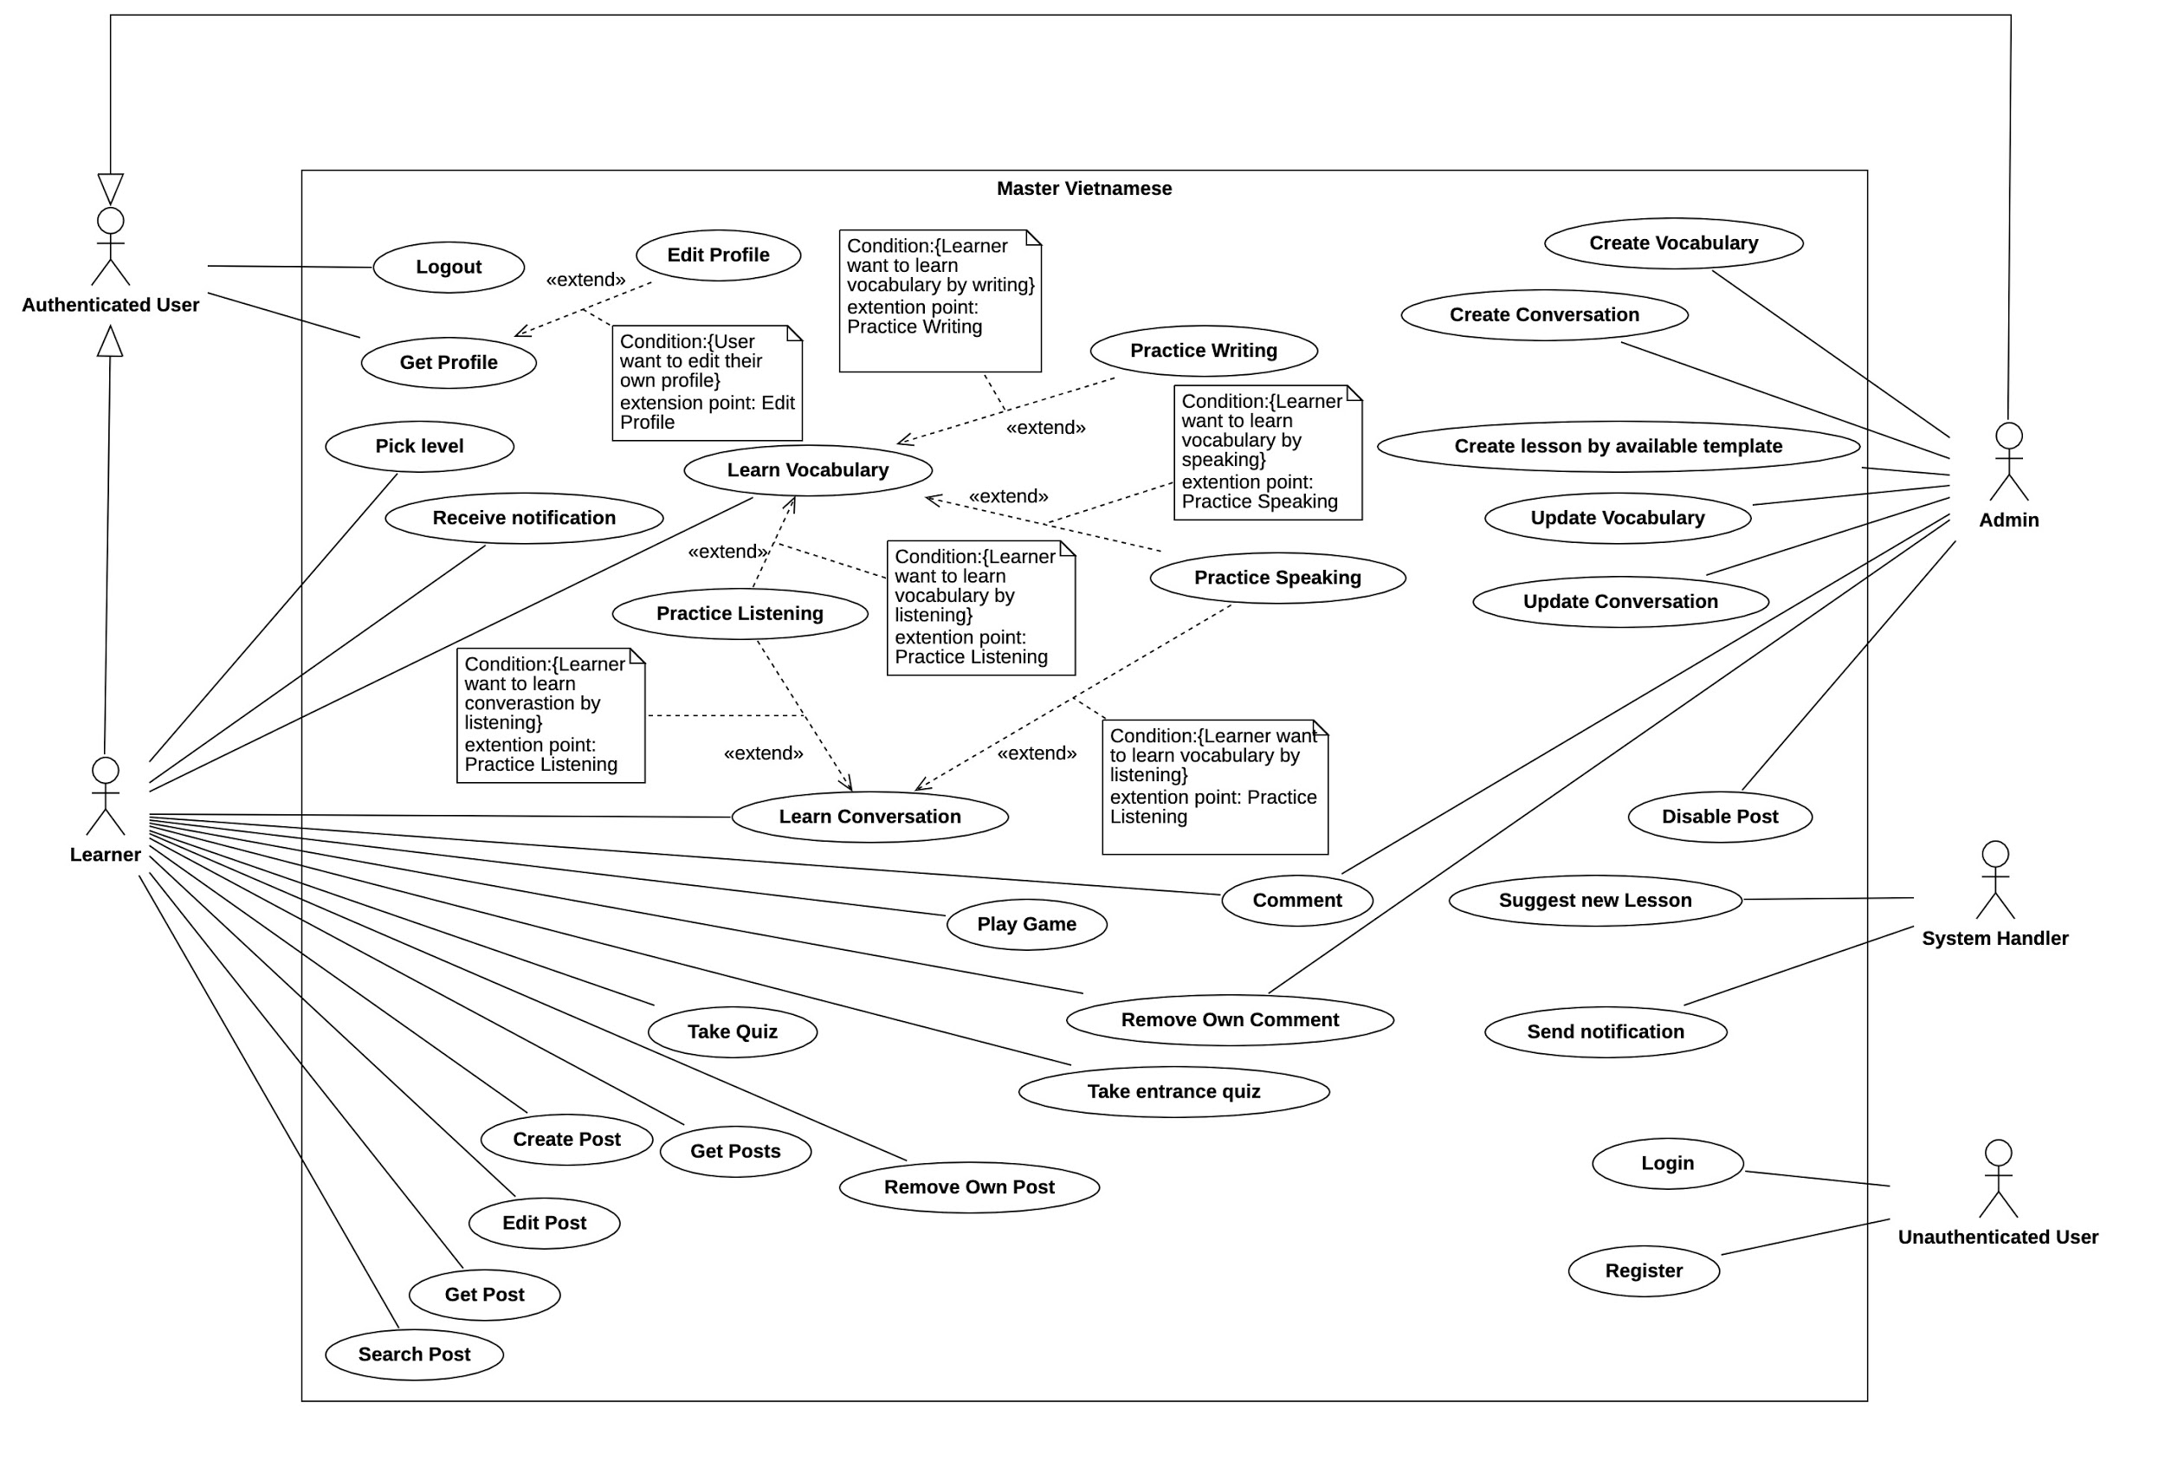

###### figure 1: Use Case Diagram

#### b. System Actors

|  |  |  |
| --- | --- | --- |
| **#** | **Actor** | **Description** |
| 1 | Administrator |  |
| 2 | System Handler |  |
| 3 | Learner |  |
| 4 | Authenticated User |  |
| 5 | Guest |  |

#### c. Use Cases List

|  |  |  |  |
| --- | --- | --- | --- |
| **ID** | **Use Case** | **Primary Actors** | **Secondary Actors** |
| 01 | Login | Guest |  |
| 02 | Sign up | Guest |  |
| 03 | Get Profile | Authenticated User |  |
| 04 | Logout | Authenticated User |  |
| 05 | Select Level | Learner |  |
| 06 | Study Lesson | Learner |  |
| 07 | Learn Vocabulary | Learner |  |
| 08 | Learn Conversation | Learner |  |
| 09 | Take quiz | Learner |  |
| 10 | Play Game | Learner |  |
| 11 | Take Entrance Quiz | Learner |  |
| 12 | Get Post | Learner |  |
| 13 | Get Posts | Learner |  |
| 14 | Create Post | Learner |  |
| 15 | Edit Post | Learner |  |
| 16 | Search Post | Learner |  |
| 17 | Comment | Learner | Administrator |
| 18 | Remove Own Comment | Learner | Administrator |
| 19 | Remove Own Post | Learner |  |
| 20 | Create New Lesson | Administrator |  |
| 21 | Create Vocabulary | Administrator |  |
| 22 | Create Conversation | Administrator |  |
| 23 | Create lesson by available form | Administrator |  |
| 24 | Update Lesson | Administrator |  |
| 25 | Update Vocabulary | Administrator |  |
| 26 | Update Conversation | Administrator |  |
| 27 | Suggest New Lesson | System Handler |  |
| 28 | Send Notification | System Handler |  |

### 2.2 Use case detail Learner

#### a. Select Level

|  |  |  |  |
| --- | --- | --- | --- |
| UC ID and Name: | **UC5 - Select Level** | | |
| Created By: | BaoHQ | Date Created: | Oct 20, 2020 |
| Primary Actor: | Learner | Secondary Actors: |  |
| Trigger: | Login button | | |
| Description: | List all levels after the learner registered a new account. We have two levels that learner can choose:   * Beginner: For users who do not have any knowledge about Vietnamese and they want to start learning from the beginning. * Qualification Test: For users who have knowledge about Vietnamese. At this option, users need to take an entrance quiz to determine their level | | |
| Preconditions: | PRE-1: Learner must login new account to the application. | | |
| Post-conditions: | POST-1: If learner choose beginner, system will set level is “Beginner”, and show all beginner lesson for learner. POST-2: If learner choose qualification test system will load quiz for learner to take a test and base on learner result to set level. | | |
| Normal Flow: | |  |  | | --- | --- | | Learner | Mobile Application | | 1.a. Learner login to the application with new account.  2.a. Learner choose level beginner | 1.1.a Display choose level screen with 2 methods: Beginner and Qualification Test.  2.1.a Display all lessons belong to level beginner | | | |
| Alternative Flows: | |  |  | | --- | --- | | Learner | Mobile Application | | 1.b. Learner login to the application with new account.  2.b. Learner choose qualification test.  3.b. Learner take quiz and submit  [exception] | 1.1.b. Display choose level screen with two methods: Beginner and Qualification Test.  2.1.b. Display quiz for learner to take a test.  3.1.b. Base on result to set level for learner and display all lesson belong to that level. | | | |
| Exceptions: | Learner shut down application while taking quiz, system will not set level for that learner and learner have to choose level again | | |
| Priority: | High | | |
| Frequency of Use: | When user login with new account. | | |
| Business Rules: | BR-1: Must login to the application.  BR-19: Must login with new account. | | |
| Other Information: | Learner must choose level before get to the lesson screen | | |
| Assumptions: | Assume that learner already have level then skip this use case.  If user want to choose level again then use this use case to set level again. | | |

#### b. Login

|  |  |  |  |
| --- | --- | --- | --- |
| ID and Name: | **UC-01 - Login** | | |
| Created By: | TuongDM | Date Created: | Oct 20, 2020 |
| Primary Actor: | Guest | Secondary Actors: |  |
| Description: | Guests sign in to the application  There are three ways to login to the application:   * Login by username and password * Login by Facebook * Login by Gmail | | |
| Trigger: | Login button, Facebook button, Gmail button | | |
| Preconditions: | PRE-1. Guest must have an account  PRE-2. Guest must have Facebook account  PRE-3. Guest must have Gmail account | | |
| Post-conditions: | POST-1: If the account already has level then skip the choose level screen to the display all lesson screen.  POST-2: If the account does not have level then show the choose level screen. | | |
| Normal Flow: | |  |  | | --- | --- | | Learner | Mobile Application | | 1.a. Guest opens the application  2.a Guest enters username and password.  [exception 1]  3.a Guest presses Sign In button  [exception 2] | 1.1.a. Show login screen  3.1.a. System authenticate user that login has been success and allow user to access the application | | | |
| Alternative Flows: | |  |  | | --- | --- | | Learner | Mobile Application | | 1.b. Guest opens the application  2.b. Guest logins with Facebook method | 1.1.b. Show login screen  2.1.b. Choose Facebook account to login to the application |  |  |  | | --- | --- | | Learner | Mobile Application | | 1.c. Guest opens the application  2.c. Guest logins with Gmail method | 1.1.c. Show login screen  2.1.c. Choose Gmail account to login to the application | | | |
| Exceptions: | Exception 1: Guest does not fill username and password field  Exception 2: Invalid username or password | | |
| Priority: | High | | |
| Frequency of Use: | Whenever guests want to login to the system. | | |
| Business Rules: | BR-07 | | |
| Other Information: | Password must be encrypt using SHA-256 | | |
| Assumptions: | Assume that guest logins with invalid account system must alert message “Invalid username or password” to guest and let them login again. | | |

#### c. Sign Up

|  |  |  |  |
| --- | --- | --- | --- |
| ID and Name: | **UC-02 - Sign Up** | | |
| Created By: | TuongDM | Date Created: | Oct 20, 2020 |
| Primary Actor: | Guest | Secondary Actors: |  |
| Description: | Guest enters their username, password, email, and nation then presses “Sign up” to register a new account. All field must be validate before sign up:   * Username is required. * Email must be valid format. * Password must be more than 8 characters. * Nation is required. | | |
| Trigger: | Sign up link | | |
| Preconditions: | PRE-1: Guest want to create new account. | | |
| Post-conditions: | POST-1: Create new account for user and navigate to login page | | |
| Normal Flow: | |  |  | | --- | --- | | Learner | Mobile Application | | 1.a. Guest pressed on sign up link  2.a. Guest enter username, password, email, nation.  [exception 1]  3.a. Guest press sign up button  [exception 2] | 1.1.a. Show sign up screen.  3.1.a System save all user information and create new account for user. | | | |
| Alternative Flows: | N/A | | |
| Exceptions: | Exception 1: Guest does not fill one of the fields required.  Exception 2: Username is duplicate. | | |
| Priority: | High | | |
| Frequency of Use: | Whenever guest want to create new account | | |
| Business Rules: | BR-08, | | |
| Other Information: | Password must be encrypt using SHA-256.  Email must be valid format.  Password length are from 8 to 16 characters. | | |
| Assumptions: | Assume that guest sign up with existed username, system will throw an alert message “This username already taken”.  If field is blank throw an alert message “This field is required”.  If password length is shorter than 8 or longer than 16 throws an alert message “Password length are from 8 to 16 characters”. | | |

#### d. Get Profile

|  |  |  |  |
| --- | --- | --- | --- |
| ID and Name: | **UC-03 - Get Profile** | | |
| Created By: | AnhND | Date Created: | Oct 22, 2020 |
| Primary Actor: | Authenticated User | Secondary Actors: |  |
| Description: | Get all authenticate user profile include:   * Username * Learning progress * Profile picture * Settings | | |
| Trigger: | User icon in display lesson screen. | | |
| Preconditions: | PRE-1: Learner must sign in with their account  PRE-2: Learner must sign in with their Facebook account  PRE-3: Learner must sign in with their Google account  PRE-4: Learner must already have level. | | |
| Post-conditions: | POST-1: Display learner profile screen. | | |
| Normal Flow: | |  |  | | --- | --- | | Learner | Mobile Application | | 1.a. Learner must already login to the system.  2.a. Click on the user icon in the lesson screen.  [exception] | 1.1.a. Show the lesson screen.  2.1.a Show the profile screen include: user name, user avatar, user progress, settings button | | | |
| Alternative Flows: | N/A | | |
| Exceptions: | Cannot connect to database to get user profile. | | |
| Priority: | High | | |
| Frequency of Use: | Whenever user click on profile tab | | |
| Business Rules: | BR-01 | | |
| Other Information: | N/A | | |
| Assumptions: | Assume that learner want to view or update their profile this screen will show:   * User name * User progress (show by progress bar) * User avatar (enable edit avatar) * Settings button * Logout button | | |

#### e. Logout

|  |  |  |  |
| --- | --- | --- | --- |
| ID and Name: | **UC-04 - Logout** | | |
| Created By: | AnhND | Date Created: | Oct 22, 2020 |
| Primary Actor: | Authenticated User | Secondary Actors: |  |
| Description: | Authenticated User logout of the system. | | |
| Trigger: | Authenticated user press the logout button in the profile tab to logout their account. | | |
| Preconditions: | PRE-1: Guest must sign in with their account  PRE-2: Guest must sign in with their Facebook account  PRE-3: Guest must sign in with their Google account | | |
| Post-conditions: | Leaner log out the application and navigate to login screen. | | |
| Normal Flow: | |  |  | | --- | --- | | Learner | Mobile Application | | 1.a. Learner press on profile icon in lesson screen.  2.a. Learner press on Log Out button.  [exception] | 1.1.a. Show the profile screen.  2.1.a System log out the user’s account. | | | |
| Alternative Flows: | N/A | | |
| Exceptions: | Cannot logout of the system | | |
| Priority: | High | | |
| Frequency of Use: | Whenever authenticated user want to logout | | |
| Business Rules: | BR-01 | | |
| Other Information: | After log out the user’s account system must navigate to login screen | | |
| Assumptions: | N/A | | |

#### f. Study Lesson

|  |  |  |  |
| --- | --- | --- | --- |
| ID and Name: | **UC-06 - Study Lesson** | | |
| Created By: | AnhND | Date Created: | Oct 22, 2020 |
| Primary Actor: | Learner | Secondary Actors: |  |
| Description: | List all the lessons to the lesson tab screen for learner base on t3 levels:   * Beginner * Intermediate * Advance | | |
| Trigger: | After learner login with account that already have level. | | |
| Preconditions: | PRE-1: Must login to the system  PRE-2: Account must already have level | | |
| Post-conditions: | POST-1: Navigate to lesson screen and display all the lessons belong to that level. | | |
| Normal Flow: | |  |  | | --- | --- | | Learner | Mobile Application | | 1.a. Learner login to the application  [exception] 2.a. Learner presses on one of the lessons | 1.1.a. Show the lesson screen.  2.1.a Show lesson detail screen include: Vocabulary, Conversation, Quiz. | | | |
| Alternative Flows: | |  |  | | --- | --- | | Learner | Mobile Application | | 1.b. Learner click on the suggest lesson notification. | 1.1.b. Open application and navigate to the suggest lesson. | | | |
| Exceptions: | Fail to load lessons | | |
| Priority: | High | | |
| Frequency of Use: | Whenever learner login to the system or re-open the application. | | |
| Business Rules: | BR1, BR2, BR3 | | |
| Other Information: | Must display lesson belong to that level and lock all the lessons that have not unlock yet. | | |
| Assumptions: | Assume that learner has done the quiz in lesson and reach the required mark, system will unlock next lesson.  If learner presses on lock lesson, system will show alert message “Please unlock above lesson to unlock this lesson’. | | |

#### g. Learn Vocabulary

|  |  |  |  |
| --- | --- | --- | --- |
| ID and Name: | **UC-07 - Learn Vocabulary** | | |
| Created By: | CuongHX | Date Created: | Oct 22, 2020 |
| Primary Actor: | Learner | Secondary Actors: |  |
| Description: | After choose lesson, choose the vocabulary method. In the vocabulary method include:   * Learn by flashcard * Learn by writing * Learn by speaking * Learn by arrange word | | |
| Trigger: | Learner presses on the vocabulary method in lesson detail. | | |
| Preconditions: | PRE-1. Learner must login to the application  PRE-2. Learner must choose the level  PRE-3. Learner must choose the lesson  PRE-4: Guest must choose a vocabulary method | | |
| Post-conditions: | POST-1: Show vocabulary in flashcard  POST-2: Show vocabulary in writing method  POST-3: Show vocabulary in speaking method  POST-4: Show vocabulary in arrange word method | | |
| Normal Flow: | |  |  | | --- | --- | | Learner | Mobile Application | | 1.a. Learner choose one lesson.  2.a. Learner choose vocabulary method.  [exception 1]  3.a. Press “next” button to change to writing method.  4.a. Press the volume button to listen to the sound and type what learner hear.  [exception 2]  5.a. Press the record button to record the above word.  [exception 3]  6.a. Learner arrangement the word | 1.1.a. Show lesson detail screen.  2.1.a. Show vocabulary for learner to learner and flashcard method.  3.1.a. Display writing method  4.1.a. Check what learner just type, if learner type it right system will change to speaking method. Else learner has to type again.  5.1.a. Check what learner just speak, if learner speak it right system will change to arrange word method. Else learner has to speak again.  6.1.a. Check the arrange word. If learner arrange it right system will change to next word. Else learner has to arrange again. | | | |
| Alternative Flows: | N/A | | |
| Exceptions: | Exception 1: Cannot load vocabularies.  Exception 2: Invalid data.  Exception 3: Does not have permission to record. | | |
| Priority: | Medium | | |
| Frequency of Use: | Whenever learner learns vocabulary method. | | |
| Business Rules: | BR1, BR2 | | |
| Other Information: | Must count the vocabularies and show for learner that lesson have how many vocabularies. | | |
| Assumptions: | Assume that learner want to learn vocabulary, system must show the vocabulary match with the lesson and throw all these learning methods:   * Learn by flashcard * Learn by writing * Learn by speaking * Learn by arrange word | | |

#### h. Learn Conversation

|  |  |  |  |
| --- | --- | --- | --- |
| ID and Name: | **UC-08 - Learn Conversation** | | |
| Created By: | BaoHQ | Date Created: | Oct 22, 2020 |
| Primary Actor: | Learner | Secondary Actors: |  |
| Description: | After choose lesson, choose the conversation method. In the conversation method include:   * Learn by speaking * Learn by arrange sentence | | |
| Trigger: | Learners click on the conversation button in lesson detail. | | |
| Preconditions: | PRE-1. Learner must login to the application  PRE-2. Learner must choose the level  PRE-3. Learner must choose the lesson  PRE-4: Guest must choose a conversation method | | |
| Post-conditions: | POST-1: Show conversation in speaking method  POST-2: Show conversation in arrange sentence method | | |
| Normal Flow: | |  |  | | --- | --- | | Learner | Mobile Application | | 1.a. Learner choose one lesson.  2.a. Learner choose conversation method.  [exception 1]  3.a. Learner press on Learn Now button  4.a. Press the record button to record the above sentence.  [exception 2]  5.a. Learner arrangement the sentence | 1.1.a. Show lesson detail screen.  2.1.a. Show conversation for learner to learner.  3.1.a. Display speaking method  4.1.a. Check what learner just speak, if learner speak it right system will change to arrange sentence method. Else learner has to speak again.  6.1.a. Check the arrange sentence. If learner arrange it right system will change to next sentence. Else learner has to arrange again. | | | |
| Alternative Flows: | N/A | | |
| Exceptions: | Exception 1: Cannot load vocabularies.  Exception 2: Does not have permission to record. | | |
| Priority: | High | | |
| Frequency of Use: | Whenever learner learns conversation method. | | |
| Business Rules: | BR1, BR2 | | |
| Other Information: | Must count the conversations and show for learner that lesson have how many conversations. | | |
| Assumptions: | Assume that learner want to learn conversation, system must show the conversation match with the lesson and learner must learn through all these learning methods:   * Learn by speaking * Learn by arrange sentence | | |

#### i. Take Quiz

|  |  |  |  |
| --- | --- | --- | --- |
| ID and Name: | **UC-09 - Take Quiz** | | |
| Created By: | BaoHQ | Date Created: | Oct 23, 2020 |
| Primary Actor: | Learner | Secondary Actors: |  |
| Description: | Every lesson has a quiz and learner can take one or more quizzes depending on the lesson. | | |
| Trigger: | Learners click on the quiz button in lesson detail. | | |
| Preconditions: | PRE-1. Learner must login to the application  PRE-2. Learner must choose the level  PRE-3. Learner must choose the lesson  PRE-4. Learner must start quiz | | |
| Post-conditions: | POST-1: Show question and answer for learner and learner can take quiz  POST-2: After learner finish there quiz the system will show the result | | |
| Normal Flow: | |  |  | | --- | --- | | Learner | Mobile Application | | 1.a. After login learner choose the lesson.  2.a. Learner choose quiz method  [exception 1]  3.a. Learner press on Quiz Now button.  4.a. Choose answer and finish all quiz  [exception 2]  5.a. Choose “Back to lesson screen” button. | 1.1.a. Show lesson detail screen.  2.1.a. Show Quiz detail for learner.  3.1.a. Show all questions and answers belong to that lesson.  4.1.a. After learner finishes the quiz. Check all the answers that learner has answered and return the result screen.  5.1.a. Load all lessons and navigate to the lesson screen. | | | |
| Alternative Flows: | |  |  | | --- | --- | | Learner | Mobile Application | | 1.b. After login learner choose the lesson.  2.b. Learner choose quiz method  3.b. Learner press on Quiz Now button.  4.b. Choose answer and finish all quiz  5.b. Choose “Review” button. | 1.1.b. Show lesson detail screen.  2.1.b. Show Quiz detail for learner.  3.1.b. Show all questions and answers belong to that lesson.  4.1.b. After learner finishes the quiz. Check all the answers that learner has answered and return the result screen.  5.1.b. Load all the answers that user had answered before. |  |  |  | | --- | --- | | Learner | Mobile Application | | 1.c. After login learner choose the lesson.  2.c. Learner choose quiz method  3.c. Learner press on Quiz Now button.  4.c. Choose answer and finish all quiz  5.c. Choose “Re-attempt” button.  [exception 3] | 1.1.c. Show lesson detail screen.  2.1.c. Show Quiz detail for learner.  3.1.c. Show all questions and answers belong to that lesson.  4.1.c. After learner finishes the quiz. Check all the answers that learner has answered and return the result screen.  5.1.c. Reload new quiz for learner. | | | |
| Exceptions: | Exception 1: Cannot load quiz  Exception 2: Cannot load the result for learner  Exception 3: Cannot load the re-attempt quiz for learner | | |
| Priority: | High | | |
| Frequency of Use: | Whenever a learner wants to take a quiz. | | |
| Business Rules: | BR1, BR2, BR3 | | |
| Other Information: | If learner cancels while taking a quiz, this quiz will reset and all quiz progress will be shut down and the result will be not saved.  If learner take a quiz and the result mark is above 8 then unlock next lesson for learner. | | |
| Assumptions: | Assume that learner take quiz and quiz result is not above 8. Then learner must take that quiz again to unlock next lesson. | | |

#### j. Take Entrance Quiz

|  |  |  |  |
| --- | --- | --- | --- |
| ID and Name: | **UC-09 - Take Entrance Quiz** | | |
| Created By: | BaoHQ | Date Created: | Oct 23, 2020 |
| Primary Actor: | Learner | Secondary Actors: |  |
| Description: | When learners know a little bit about Vietnamese and they don’t want to learn from the beginning. There is a Take Qualification Test method that will give users a test and evaluate them. | | |
| Trigger: | 1. Learner logins with an account does not have level.  2. Learner clicks on “Test Qualification”. | | |
| Preconditions: | PRE-1. Learner must login to the application with a new account  PRE-2. Learner must choose the “Test Qualification” | | |
| Post-conditions: | POST-1: Show the qualification test questions and answers.  POST-2: Show the result after learner has done the test. POST3-: Show the level that learner belong to. | | |
| Normal Flow: | |  |  | | --- | --- | | Learner | Mobile Application | | 1.a. Learner logins to application with new account. [exception 1]  2.a. Learner chooses the “Test Qualification”. [exception 2]  3.a. Choose answer and finish all quiz.  4.a. Press “OK” button. [exception 3] | 1.1.a. Show choose level screen.  2.1.a. System will display all questions and answers for the learner.  3.1.a. After learner finishes the quiz. Check all the answers that learner has answered and return the result screen.  5.1.a. Load lesson screen base on the level that learner has been evaluate. | | | |
| Alternative Flows: | N/A | | |
| Exceptions: | Exception 1: Invalid username or password.  Exception 2: Cannot load qualification quiz for learner.  Exception 3: Cannot load lessons for learner. | | |
| Priority: | High | | |
| Frequency of Use: | Whenever a learner wants to take a qualification test. | | |
| Business Rules: | BR1, BR2, BR3 | | |
| Other Information: | If a learner cancels while taking a quiz, this quiz will reset and all quiz progress will be shut down and the result will be not saved. | | |
| Assumptions: | Assume that learner take qualification test and the mark like:   * From 0 to 6: Beginner Level * From 6 to 8: Intermediate Level * From 8 to 10: Advance level | | |

#### j. Play Game

|  |  |  |  |
| --- | --- | --- | --- |
| ID and Name: | **UC-09 - Play Game** | | |
| Created By: | AnhND | Date Created: | Oct 23, 2020 |
| Primary Actor: | Learner | Secondary Actors: |  |
| Description: | Learner plays games about Vietnamese language to practice Vietnamese language skills. | | |
| Trigger: | Learner chooses the “Game” tab on home screen | | |
| Preconditions: | PRE-1. Guest musts login to the mobile application.  PRE-2. Learner musts learn at least one lesson. | | |
| Post-conditions: | Success: D  Fail: Leaner does not start any lesson. | | |
| Normal Flow: | 1. Learner chooses the “Game” tab on the home screen. 2. Learner chooses a game to play. 3. Learner presses “Start” button to play a game which has been chosen | | |
| Alternative Flows: | N/A | | |
| Exceptions: | Learner does not start to learn any lesson. | | |
| Priority: | Medium | | |
| Frequency of Use: | Whenever a learner wants to play a game. | | |
| Business Rules: | 8BR1, BR6 | | |
| Other Information: | N/A | | |
| Assumptions: | N/A | | |

#### k. Create post

|  |  |  |  |
| --- | --- | --- | --- |
| ID and Name: | **UC-15 - Create Post** | | |
| Created By: | AnhND | Date Created: | 25 Oct, 2020 |
| Primary Actor: | Learner | Secondary Actors: |  |
| Description: | This use case allows the learner to create a new post with audio or video. | | |
| Trigger: | Learner presses on the “Create new post” button on the News feed screen. | | |
| Preconditions: | PRE-1. Guest musts login to the mobile application. | | |
| Post-conditions: | Success: Display message “Create post success” and navigate to News feed screen.  Fail: Display message “Create post failed”. | | |
| Normal Flow: | |  |  | | --- | --- | | Learner | Mobile Application | | 1. Learner presses on the “Create new post” button on the News feed screen.  2. Learner enters title and content of new post  3. Learner records audio or video  4. Learner presses on “Post" button | 1.1. Mobile Application displays create a new post screen with title input, content input, video and audio record option.  4.1 Mobile application save post to server. | | | |
| Alternative Flows: | N/A | | |
| Exceptions: | 4.1.a. Mobile application detects invalid information of post and return message to user | | |
| Priority: | High | | |
| Frequency of Use: | Whenever a learner wants to create a new post. | | |
| Business Rules: | BR-11: Must have title in create post  BR-12: Must have content in create post  BR-13: Audio record max length is 2 minutes  BR-14: Video record max length is 2 minutes | | |
| Other Information: | N/A | | |
| Assumptions: | N/A | | |

#### l. Edit post

|  |  |  |  |
| --- | --- | --- | --- |
| ID and Name: | **UC-16 - Edit Post** | | |
| Created By: | AnhND | Date Created: | 25 Oct, 2020 |
| Primary Actor: | Learner | Secondary Actors: |  |
| Description: | This use case allows the learner to edit their post. | | |
| Trigger: | Learner chooses the “Edit post” option on the Post detail screen. | | |
| Preconditions: | PRE-1. Guest musts login to the mobile application.  PRE-2. Learner musts have their own post. | | |
| Post-conditions: | Success: Display message “Edit post success” and navigate to News feed screen.  Fail: Display message “Edit post failed”. | | |
| Normal Flow: | |  |  | | --- | --- | | Learner | Mobile Application | | 1. Learner presses on the “Create new post” button on the News feed screen.  2. Learner enters new title and content  3. Learner records new audio or video  4. Learner presses on “Save" button | 1.1. Mobile Application displays edit post screen with title input, content input, video and audio record option. Edit post screen show all current information of post  4.1 Mobile application save post to server. | | | |
|
| Alternative Flows: | N/A | | |
| Exceptions: | 4.1.a. Mobile application detects invalid information of post and return message to user | | |
| Priority: | High | | |
| Frequency of Use: | Whenever a learner wants to edit their post. | | |
| Business Rules: | BR-11: Must have title in create post  BR-12: Must have content in create post  BR-13: Audio record max length is 2 minutes  BR-14: Video record max length is 2 minutes | | |
| Other Information: | N/A | | |
| Assumptions: | N/A | | |

#### l. Search Post

|  |  |  |  |
| --- | --- | --- | --- |
| ID and Name: | **UC-17- Search Post** | | |
| Created By: | AnhND | Date Created: | 25 Oct, 2020 |
| Primary Actor: | Learner | Secondary Actors: |  |
| Description: | This use case allows the learner search post by title. | | |
| Trigger: | Learner chooses the “Search” icon button on the News feed | | |
| Preconditions: | PRE-1. Guest musts login to the mobile application. | | |
| Post-conditions: | Success: Display posts that have a title match to search keywords.  Fail: Display message “not found” | | |
| Normal Flow: | |  |  | | --- | --- | | Learner | Mobile Application | | 1. Learner presses on “Search” icon button on the News feed screen | 1.1. Mobile Application | | | |
| Alternative Flows: | N/A | | |
| Exceptions: | Learner enters empty search keywords | | |
| Priority: | High | | |
| Frequency of Use: | Whenever a learner wants to search a post. | | |
| Business Rules: | N/A | | |
| Other Information: | N/A | | |
| Assumptions: | N/A | | |

#### n. Get Post

|  |  |  |  |
| --- | --- | --- | --- |
| ID and Name: | **UC-13- Get Post** | | |
| Created By: | AnhND | Date Created: | 25 Oct, 2020 |
| Primary Actor: | Learner | Secondary Actors: |  |
| Description: | This use case allow learner to view detailed information of a post | | |
| Trigger: | Learner presses on a post on the News feed screen. | | |
| Preconditions: | PRE-1. Guest musts login to the mobile application. | | |
| Post-conditions: | Success: Display detailed information of chosen post  Fail: Display message “Cannot view this post”. | | |
| Normal Flow: | 1. Learner chooses a post on news feed screen 2. Application display detail informations of chosen post | | |
| Alternative Flows: | 1. Learner presses on “Notification” icon button 2. Learner presses on a notification related to a post on Notification screen 3. Application display detail informations of chose post | | |
| Exceptions: | N/A | | |
| Priority: | High | | |
| Frequency of Use: | Whenever a learner wants to view detailed information of a post. | | |
| Business Rules: | N/A | | |
| Other Information: | N/A | | |
| Assumptions: | N/A | | |

#### o. Get Posts

|  |  |  |  |
| --- | --- | --- | --- |
| ID and Name: | **UC-14- Get Posts** | | |
| Created By: | AnhND | Date Created: | 25 Oct, 2020 |
| Primary Actor: | Learner | Secondary Actors: |  |
| Description: | This use case allow learner to view list of posts | | |
| Trigger: | Learner chooses “Xin chào Việt Nam” tab on home screen | | |
| Preconditions: | PRE-1. Guest musts login to the mobile application. | | |
| Post-conditions: | Success: Display post on News feed screen  Fail: Display message “No post here” on News feed screen. | | |
| Normal Flow: | 1. Learner choose “Xin chào Việt Nam” tab on home screen 2. Application display posts on News feed screen | | |
| Alternative Flows: | 1. Learner presses on “Notification” icon button 2. Learner presses on a notification related to a post on Notification screen 3. Application display detail informations of chose post | | |
| Exceptions: | N/A | | |
| Priority: | High | | |
| Frequency of Use: | Whenever a learner wants to view posts. | | |
| Business Rules: | N/A | | |
| Other Information: | N/A | | |
| Assumptions: | N/A | | |

#### p. Comment

|  |  |  |  |
| --- | --- | --- | --- |
| ID and Name: | **UC-18- Comment** | | |
| Created By: | AnhND | Date Created: | 25 Oct, 2020 |
| Primary Actor: | Learner | Secondary Actors: | Administrator |
| Description: | This use case allow learner and administrator make a comment to a post | | |
| Trigger: | Learner press on a post to view details on News feed screen | | |
| Preconditions: | PRE-1. Guest musts login to the mobile application | | |
| Post-conditions: | Success: Display a comment on View Details of post screen  Fail: Display message “comment failed” on screen | | |
| Normal Flow: | 1. Learner or administrator enters their comment to comment input box 2. Learner or administrator presses on the “Record audio” icon button to record voice. 3. Learners or administrator presses on “Send” button to send comment 4. Application check comment:    1. Valid comment: Save comment to database and display comment to learner    2. Invalid information: Require learner to enter comment again. | | |
| Alternative Flows: | N/A | | |
| Exceptions: | Learner enters empty comment | | |
| Priority: | High | | |
| Frequency of Use: | Whenever a learner wants to comment on a post. | | |
| Business Rules: | BR-15 | | |
| Other Information: | N/A | | |
| Assumptions: | N/A | | |

### 2.3 Use case detail for Administrator

#### a. Create New Lesson

|  |  |  |  |
| --- | --- | --- | --- |
| ID and Name: | **UC-09 - Create New Lesson** | | |
| Created By: | BaoHQ | Date Created: | Oct 23, 2020 |
| Primary Actor: | Administrator | Secondary Actors: |  |
| Description: | For administrator to create new lesson to the system and add it to database | | |
| Trigger: | Administrator click on the create new lesson button on the web admin dashboard. | | |
| Preconditions: | PRE-1. Administrator must login to the web admin dashboard  PRE-2. Admin choose the create new lesson button | | |
| Post-conditions: | Success: Show all methods that will create new lesson.  Fail: Create a new lesson failed. | | |
| Normal Flow: | 1. After login, administrator chooses to create the new lesson. 2. Choose method that will create new lesson. | | |
| Alternative Flows: | N/A | | |
| Exceptions: | Error from server that cannot create new lesson. | | |
| Priority: | Medium | | |
| Frequency of Use: | Whenever administrator wants to create a new lesson. | | |
| Business Rules: | BR-01, BR-06 | | |
| Other Information: | N/A | | |
| Assumptions: | N/A | | |

#### b. Create Vocabulary

|  |  |  |  |
| --- | --- | --- | --- |
| ID and Name: | **UC-10 - Create Vocabulary** | | |
| Created By: | BaoHQ | Date Created: | Oct 23, 2020 |
| Primary Actor: | Administrator | Secondary Actors: |  |
| Description: | For administrator to create new vocabulary to the system and add it to database | | |
| Trigger: | Administrator click on the create new lesson button on the web admin dashboard. And choose method create vocabulary | | |
| Preconditions: | PRE-1. Administrator must login to the web admin dashboard  PRE-2. Administrator choose the create new lesson button  PRE-3. Administrator choose the create vocabulary method | | |
| Post-conditions: | Success: Show all methods that will create new lessons.  Fail: Create a new vocabulary failed. | | |
| Normal Flow: | 1. After login, the administrator chooses to create the new lesson.  2. Choose the create vocabulary method. | | |
| Alternative Flows: | N/A | | |
| Exceptions: | Error from server that cannot create lesson | | |
| Priority: | Medium | | |
| Frequency of Use: | Whenever administrator wants to create new lesson | | |
| Business Rules: | BR-18, BR-19 | | |
| Other Information: | Import file will use standard template | | |
| Assumptions: | N/A | | |

#### c. Create Lesson by Available Form

|  |  |  |  |
| --- | --- | --- | --- |
| ID and Name: | **UC-10 - Create Lesson By Available Form** | | |
| Created By: | BaoHQ | Date Created: | Oct 25, 2020 |
| Primary Actor: | Administrator | Secondary Actors: |  |
| Description: | For administrator to create new lesson to the system and add it to database using available form | | |
| Trigger: | Administrators click on the “Import ” button on the web admin dashboard. | | |
| Preconditions: | PRE-1. Administrator must login to the web admin dashboard  PRE-2. Administrator choose the “Import” button  PRE-3. Form must be valid | | |
| Post-conditions: | Success: Alert to admin that lesson has been added  Fail: Alert to admin that fail to add lesson and return to import screen | | |
| Normal Flow: | 1. After login, the administrator chooses to create the new lesson.  2. Choose the create vocabulary method. | | |
| Alternative Flows: | N/A | | |
| Exceptions: | Error from server that cannot create vocabulary | | |
| Priority: | Medium | | |
| Frequency of Use: | Whenever administrator wants to create a vocabulary. | | |
| Business Rules: | BR-01, BR-06 | | |
| Other Information: | N/A | | |
| Assumptions: | N/A | | |

## 3. Functional Requirements

### 3.1 System Functional Overview

#### a. Screen Flow

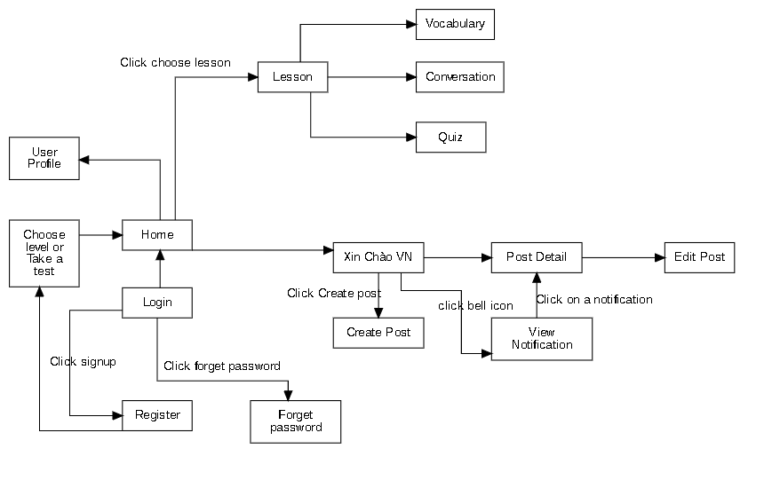

### *figure 2: Screen Flow*

#### b. Screen Details

|  |  |  |  |
| --- | --- | --- | --- |
| **Id** | **Feature** | **Screen** | **Description** |
| 01 | Login | Sign in |  |
| 02 | Login | Sign up |  |
| 03 | Login | Forget password |  |
| 04 | Learn Vietnamese | Lesson | This screen displays lessons by level of user |
| 05 | Learn Vietnamese | Lesson Details | This screen displays part of a lesson |
| 06 | Learn Vietnamese | Vocabulary | This screen allows user to learn vocabularies of a lesson |
| 07 | Learn Vietnamese | Conversation | This screen allows user to learn vocabularies of a lesson |
| 08 | Learn Vietnamese | Quiz | This screen allows user to take quiz of a lesson |
| 09 | Xin chào Việt Nam | News feed | This screen display posts for user, user can choose between “All posts” or “My posts” tab |
| 10 | Xin chào Việt Nam | Create post | This screen allows user to create their post |
| 11 | Xin chào Việt Nam | Post detail | This screen allows user to see post detail and comments, user also send their comment in this screen |
| 12 | Xin chào Việt Nam | Notification | This screen allows user to see their notification |

#### c. Screen Authorization

|  |  |  |  |
| --- | --- | --- | --- |
| **Screen** | **Role1** | **Role2** | **Role3** |
| Login | x | x | x |
| Sign up | x | x | x |
| Lessons | x |  | x |
| Lesson details | x |  | x |
| Learn Vocabulary | x |  |  |
| Learn Conversation | x |  |  |
| Do quiz | x |  |  |
| News feed | x | x |  |
| Create post | x | x |  |
| Edit post | x | x |  |
| Post details | x | x |  |
| … |  |  |  |

In which:

* Role1: Student
* Role2: Moderator
* Role3: Admin

#### d. Non-Screen Functions

*[Provide the descriptions for the non-screen system functions, i.e batch/cron job, service, API, etc.]*

|  |  |  |
| --- | --- | --- |
| **#** | **System Function** | **Description** |
| 1 | <<Function Name1>> | <<Function Name1 Description>> |
| 2 | … |  |

#### e. Entity Relationship Diagram

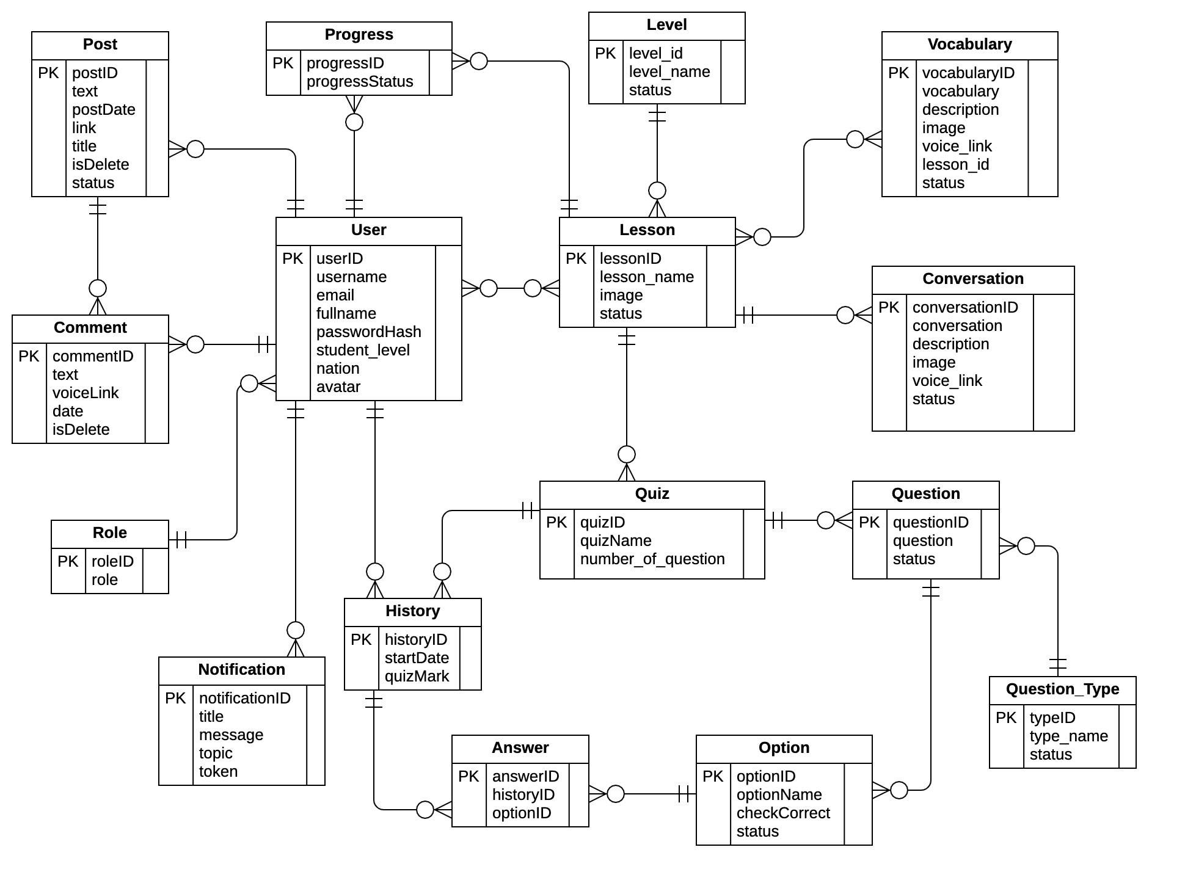

### *figure 3: ERD diagram*

|  |  |  |
| --- | --- | --- |
| **#** | **Entity** | **Description** |
| 1 | User |  |
| 2 | Lesson |  |
| 3 | Level |  |
| 4 | Vocabulary |  |
| 5 | Conversation |  |
| 6 | Quiz |  |
| 7 | Question |  |
| 8 | Option |  |
| 9 | Answer |  |
| 10 | History |  |
| 11 | Notification |  |
| 12 | Role |  |
| 13 | Post |  |
| 14 | Comment |  |
| 15 | Progress |  |
| 16 | Question_Type |  |

### 3.2 <<Feature Name 1>>

#### a. <<Function Name 1>>

*[A function can be a screen or a non-screen function (listed in the part 5.1 above). In this part, you need to provide the details on the related function, focus on mentioning below information*

* *Function trigger: how this function is triggered (navigation path, a timing frequency, etc.*
* *Function description: actors/roles, purpose, interface, data processing, etc.*
* *Screen layout: mockup prototype of the screen, sample below is for Manage Products screen*

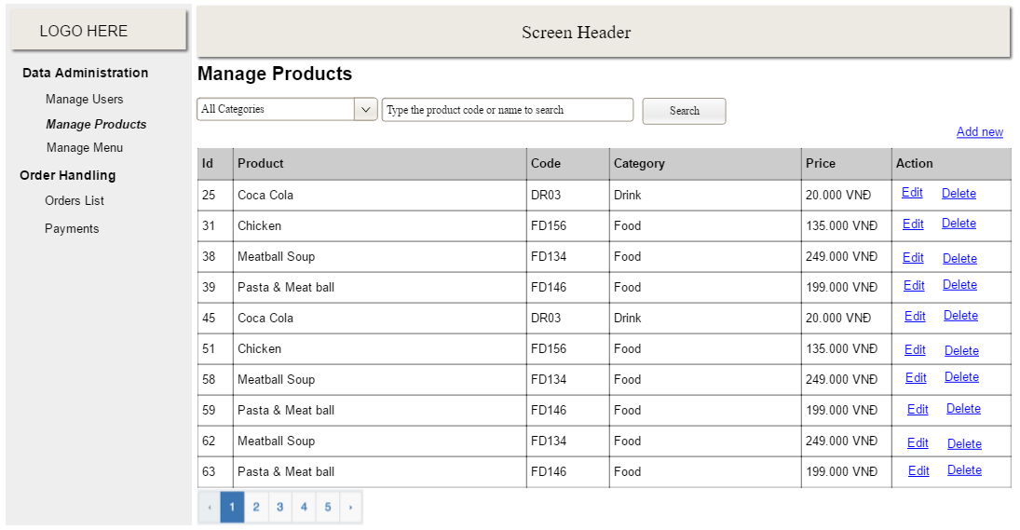

* *Function Details: provide explanation for the data, validation, functionalities (for both normal cases and abnormal cases), etc. of the function so that the reader can image how it work.*

*]*

#### b. <<Function Name 2>>

…

### 3.3 <<Feature Name 2>>

…

## 4. Non-Functional Requirements

### 4.1 External Interfaces

#### a. User Interfaces

*[Describe the logical characteristics of each interface between the software product and the users. This may include sample screen images, any GUI standards or product family style guides that are to be followed, screen layout constraints, standard buttons and functions (e.g., help) that will appear on every screen, keyboard shortcuts, error message display standards, and so on. Define the software components for which a user interface is needed. Details of the user interface design should be documented in a separate user interface specification.]*

UI-1: The Cafeteria Ordering System screen displays shall conform to the Process Impact Internet Application User Interface Standard, Version 2.0 [3].

UI-2: The system shall provide a help link from each displayed webpage to explain how to use that page.

UI-3: The webpages shall permit complete navigation and food item selection by using the keyboard alone, in addition to using mouse and keyboard combinations.

#### b. Software Interfaces

*[Describe the connections between this product and other software components (identified by name and version), including other applications, databases, operating systems, tools, libraries, websites, and integrated commercial components. State the purpose, formats, and contents of the messages, data, and control values exchanged between the software components. Specify the mappings of input and output data between the systems and any translations that need to be made for the data to get from one system to the other. Describe the services needed by or from external software components and the nature of the inte-component communications. Identify data that will be exchanged between or shared across software components. Specify non-functional requirements affecting the interface, such as service levels for responses times and frequencies, or security controls and restrictions.]*

SI-1: Cafeteria Inventory System

SI-1.1: The COS shall transmit the quantities of food items ordered to the Cafeteria Inventory System through a programmatic interface.

SI-1.2: The COS shall poll the Cafeteria Inventory System to determine whether a requested food item is available.

SI-1.3: When the Cafeteria Inventory System notifies the COS that a specific food item is no longer available, the COS shall remove that food item from the menu for the current date.

SI-2: Payroll System

The COS shall communicate with the Payroll System through a programmatic interface for the following operations:

SI-2.1: To allow a Patron to register and unregister for payroll deduction.

SI-2.2: To inquire whether a Patron is registered for payroll deduction.

SI-2.3: To inquire whether a Patron is eligible to register for payroll deduction.

SI-2.4: To submit a payment request for a purchased meal.

SI-2.5: To reverse all or part of a previous charge because a patron rejected a meal or wasn’t satisfied with it, or because the meal was not delivered per the confirmed delivery instructions.

#### c. Hardware Interfaces

*[Describe the characteristics of each interface between the software and hardware (if any) components of the system. This description might include the supported device types, the data and control interactions between the software and the hardware, and the communication protocols to be used. List the inputs and outputs, their formats, their valid values or ranges, and any timing issues developers need to be aware of. If this information is extensive, consider creating a separate interface specification document]*

No hardware interfaces have been identified.

#### d. Communications Interfaces

*[State the requirements for any communication functions the product will use, including e-mail, Web browser, network protocols, and electronic forms. Define any pertinent message formatting. Specify communication security or encryption issues, data transfer rates, handshaking, and synchronization mechanisms. State any constraints around these interfaces, such as whether e-mail attachments are acceptable or not.]*

CI-1: The COS shall send an email or text message (based on user account settings) to the Patron to confirm acceptance of an order, price, and delivery instructions.

CI-2: The COS shall send an email or text message (based on user account settings) to the Patron to report any problems with the meal order or delivery.

### 4.2 Quality Attributes

*[List all the required system characteristics (quality attributes) specification. Some of the possible attributes are provided with the guide/descriptions are mentioned here]*

#### a. Usability

*[This section includes all those requirements that affect usability. For example, specify the required training time for a normal users and a power user to become productive at particular operations specify measurable task times for typical tasks or base the new system’s usability requirements on other systems that the users know and like specify requirement to conform to common usability standards, such as IBM’s CUA standards Microsoft’s GUI standards]*

#### b. Reliability

*[Requirements for reliability of the system should be specified here. Some suggestions follow:*

*Availability—specify the percentage of time available ( xx.xx%), hours of use, maintenance access, degraded mode operations, and so on.*

*Mean Time Between Failures (MTBF) — this is usually specified in hours, but it could also be specified in terms of days, months or years.*

*Mean Time To Repair (MTTR)—how long is the system allowed to be out of operation after it has failed?*

*Accuracy—specifies precision (resolution) and accuracy (by some known standard) that is required in the system’s output.*

*Maximum Bugs or Defect Rate—usually expressed in terms of bugs per thousand lines of code (bugs/KLOC) or bugs per function-point( bugs/function-point).*

*Bugs or Defect Rate—categorized in terms of minor, significant, and critical bugs: the requirement(s) must define what is meant by a “critical” bug; for example, complete loss of data or a complete inability to use certain parts of the system’s functionality.]*

#### c. Performance

*[The system’s performance characteristics are outlined in this section. Include specific response times. Where applicable, reference related Use Cases by name.*

*Response time for a transaction (average, maximum)*

*Throughput, for example, transactions per second*

*Capacity, for example, the number of customers or transactions the system can accommodate*

*Degradation modes (what is the acceptable mode of operation when the system has been degraded in some manner)*

*Resource utilization, such as memory, disk, communications, and so forth.]*

#### d. Dependability

*[Software dependability includes a range of characteristics including reliability, security and safety. Dependable software should not cause physical or economic damage in the event of system failure. Malicious users should not be able to access or damage the system]*

##### d1. Security

*[Specify any requirements regarding security or privacy issues that restrict access to or use of the product. These could refer to physical, data, or software security. Security requirements often originate in business rules, so identify any security or privacy policies or regulations to which the product must conform. If these are documented in a business rules repository, just refer to them.]*

##### d2. Safety

*[Specify requirements that are concerned with possible loss, damage, or harm that could result from use of the product. Define any safeguards or actions that must be taken, as well as potentially dangerous actions that must be prevented. Identify any safety certifications, policies, or regulations to which the product must conform.]*

#### e. Supportability

*[This section indicates any requirements that will enhance the supportability or maintainability of the system being built, including coding standards, naming conventions, class libraries, maintenance access, and maintenance utilities.]*

#### f. Design Constraints

*[This section indicates any design constraints on the system being built. Design constraints represent design decisions that have been mandated and must be adhered to. Examples include software languages, software process requirements, prescribed use of developmental tools, architectural and design constraints, purchased components, class libraries, and so on.]*

#### g. Support Documents

*[Describes the requirements, if any, for o-line user documentation, help systems, help about notices, and so forth.]*

#### h. Purchased Components

*[This section describes any purchased components to be used with the system, any applicable licensing or usage restrictions, and any associated compatibility and interoperability or interface standards.]*

## 5. Other Requirements

### 5.1 Messages List

|  |  |  |  |  |
| --- | --- | --- | --- | --- |
| **#** | **Message code** | **Message Type** | **Context** | **Content** |
| 1 | MSG01 | Toast message | Invalid username or password | *No search result.* |
| 2 | MSG02 | In red, under the text box | Input-required fields are empty | *The * field is required.* |

### 